Establish a new directory, populate it with script files

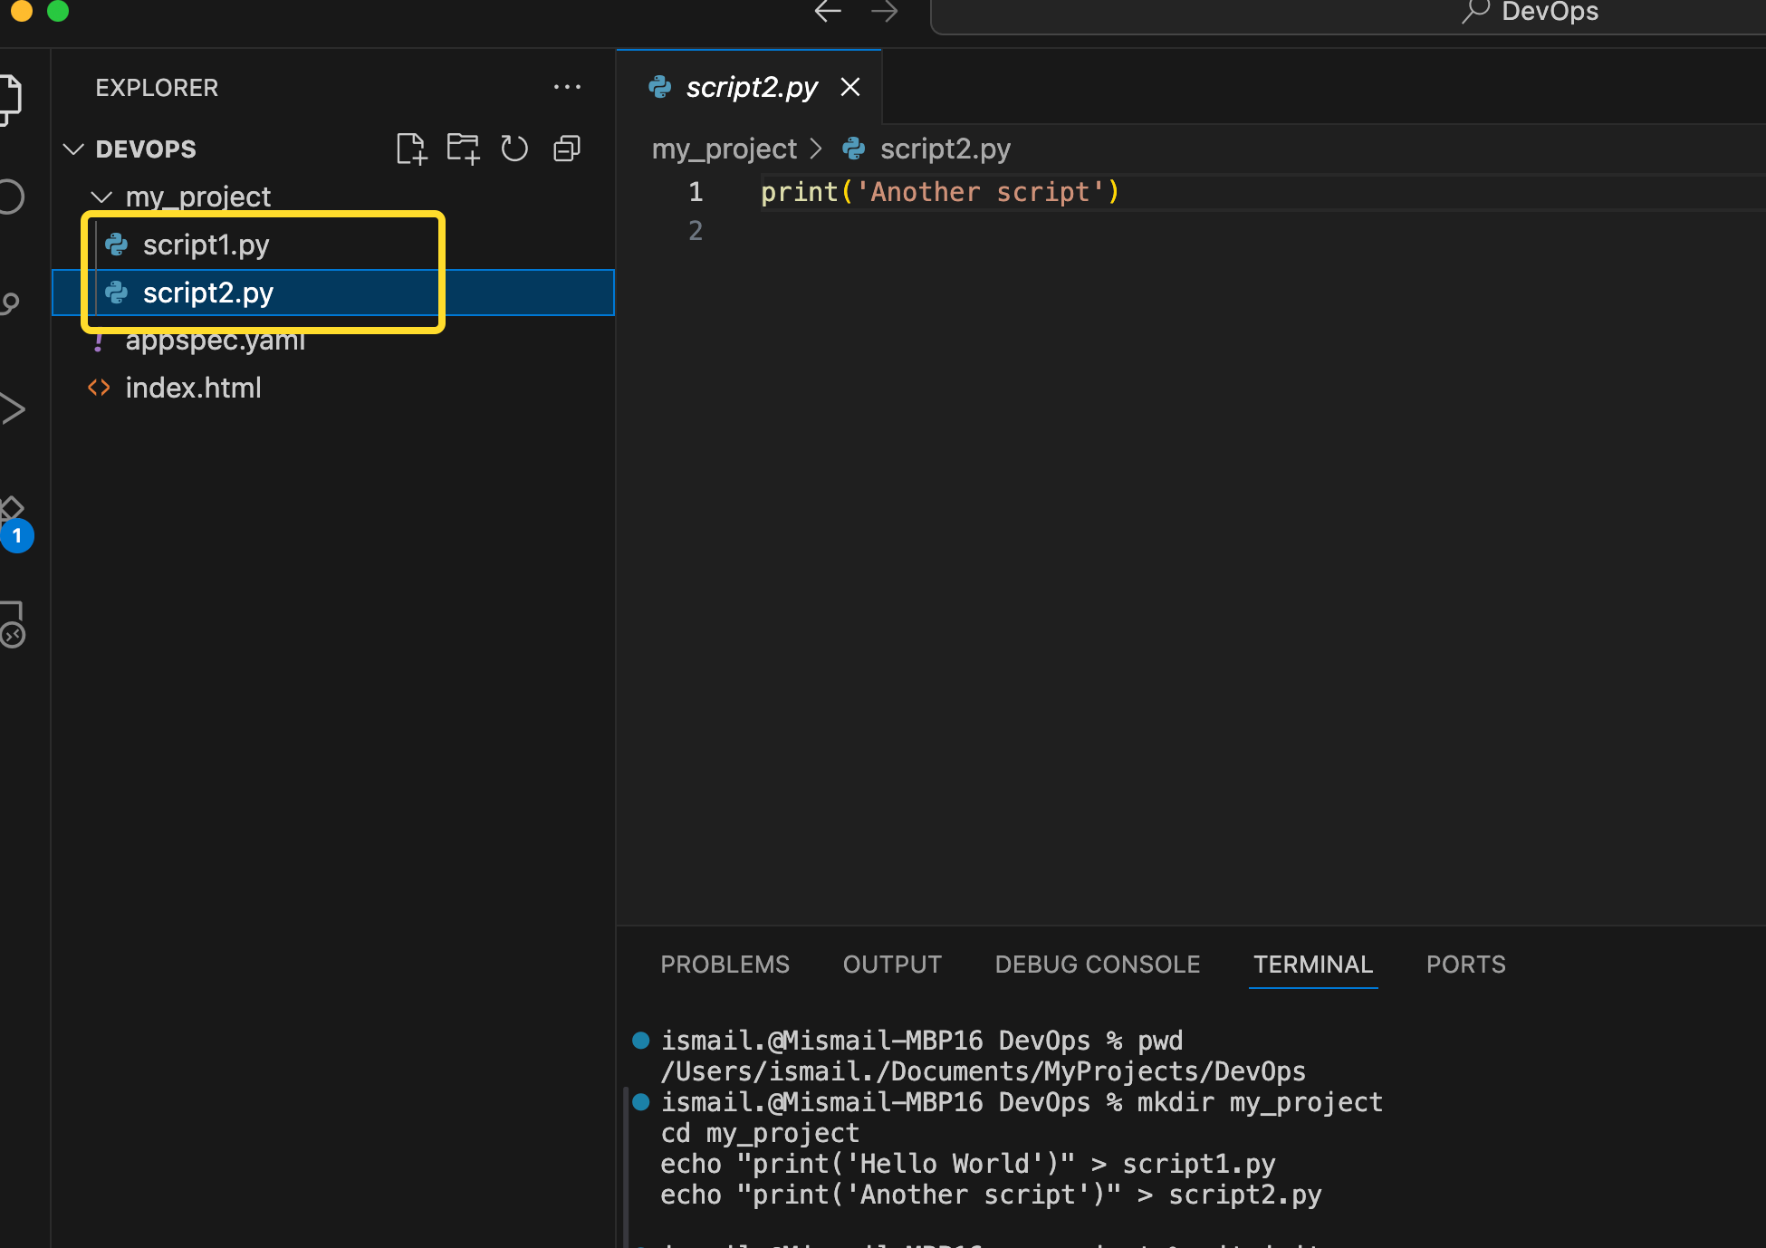

initiate an empty repository on GitHub,

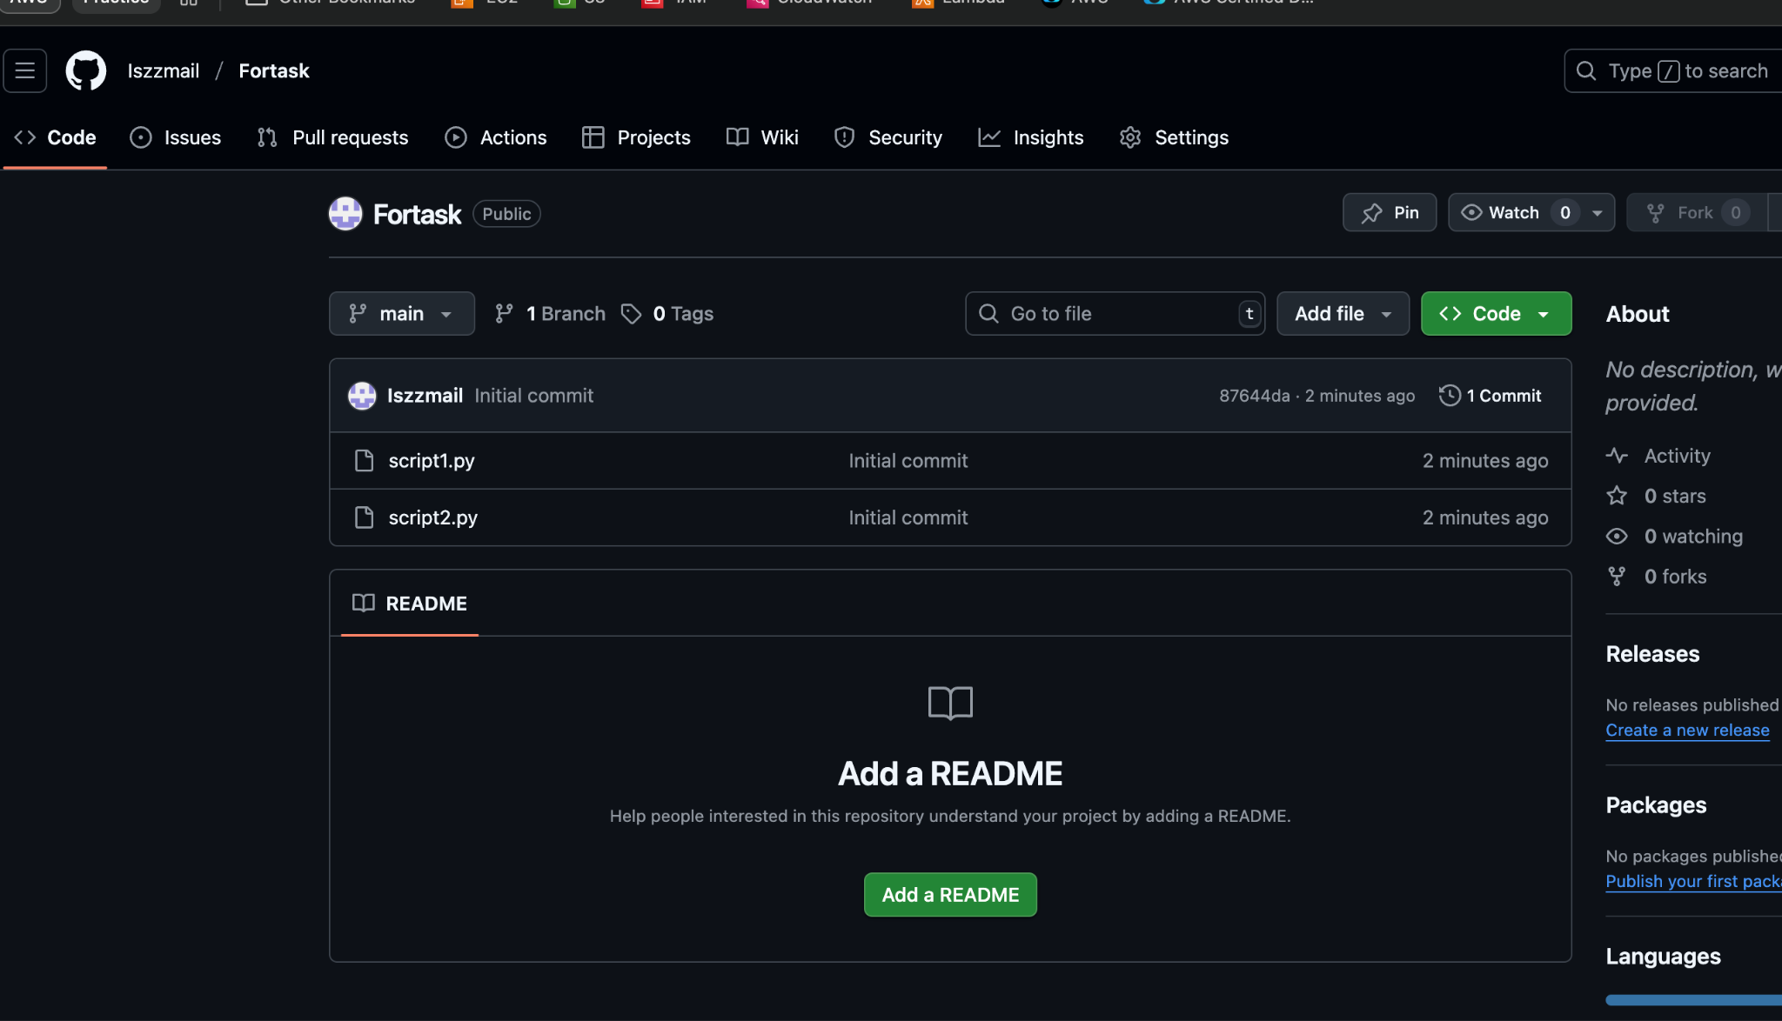

convert the local directory into a Git repository

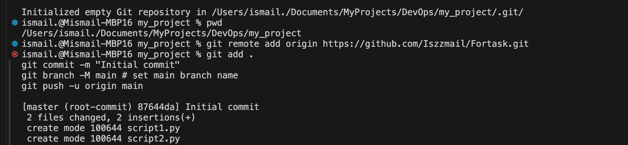

link it to GitHub for pushing the code into the repository

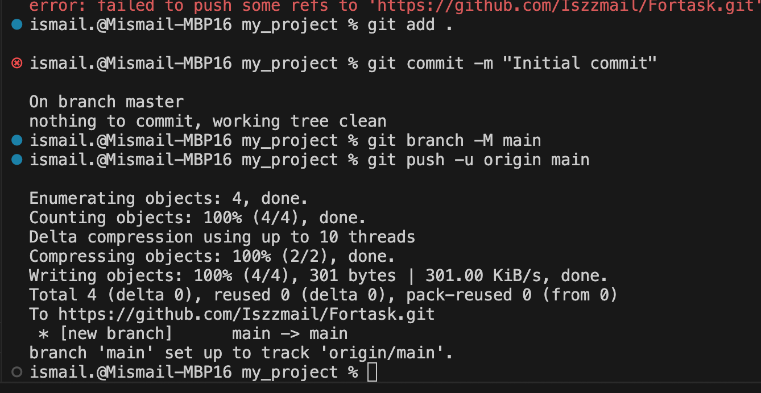

Perform merge, rebase, stash commands in following github repo

Merge

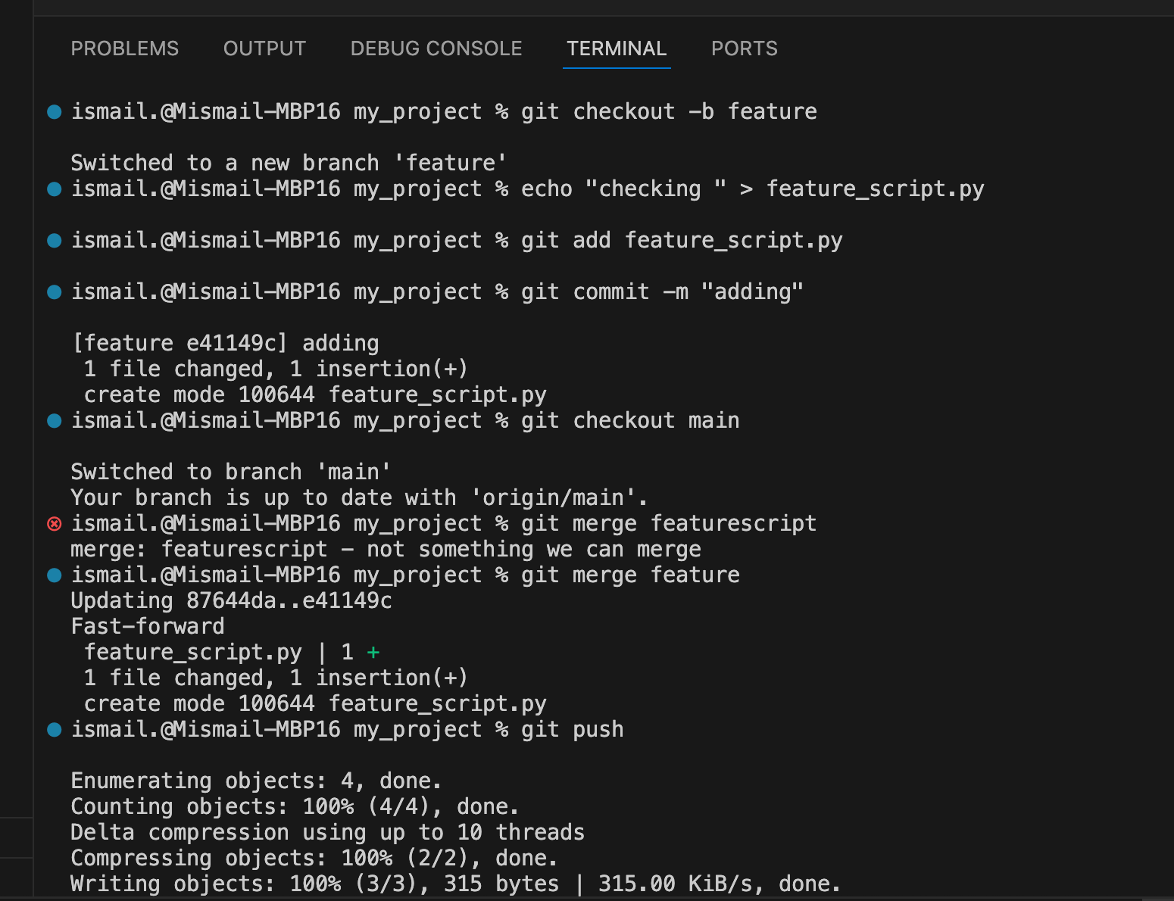

rebase

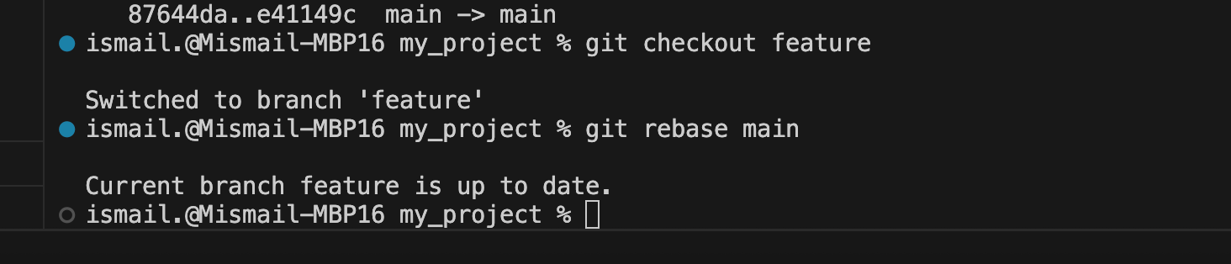

Stash

